Bike Excel Spreadsheet Data Analysis

Step 1: Remove Duplicates

Step 2: Modify Data to make it more Clear

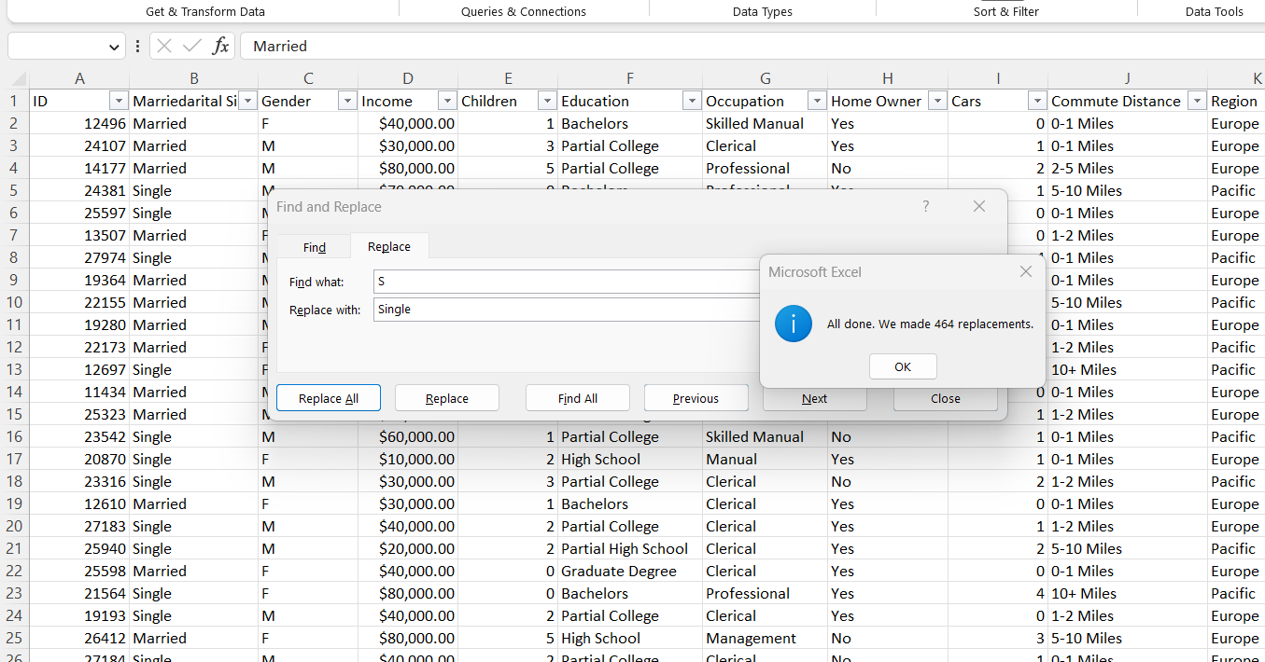

Step 3: See if there are any unique values in all the Columns

Step 4: Make a new column grouping the ages into 3-5 Categories

Step 5: Make a new Sheet and insert a Pivot table with all the information from the other sheet

Step 6: Create a graph using the information from the pivot table to compare income and purchase of a bike

Step 7: Make a board to show the number of customers that bought bikes based off their average Commute

Step 8: Create a Dashboard to show that compares the ages of the customers that purchase bikes, to make it more specific you the age column instead of age bracket to get more in depth data

Step 9: No make a Dashboard in a new sheet. Remove the Grids and then add the graphs

